Solderless Breadboard Basics

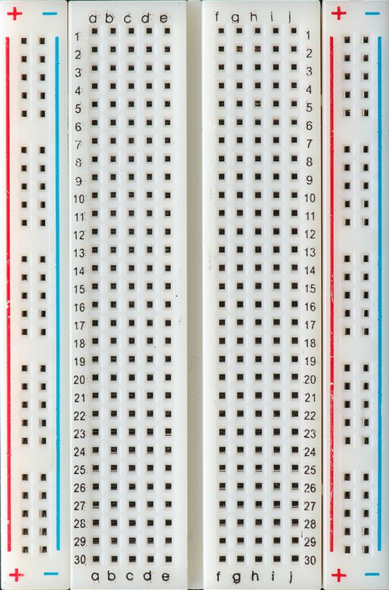
One of the most important tools for prototyping is the solderless breadboard. This is a simple device that lets us wire devices together without the need to use soldering. This lets us quickly connect devices, and easily re-wire them as the design of the hardware evolves over time. Being able to easily make changes to our hardware is an important aspect of rapid prototyping. Understanding how the breadboard is wired is essential to being able to utilize it. Each hole on the breadboard is connected to set of other holes. We can connect two devices together by placing a pin from each device into a set of connected holes.

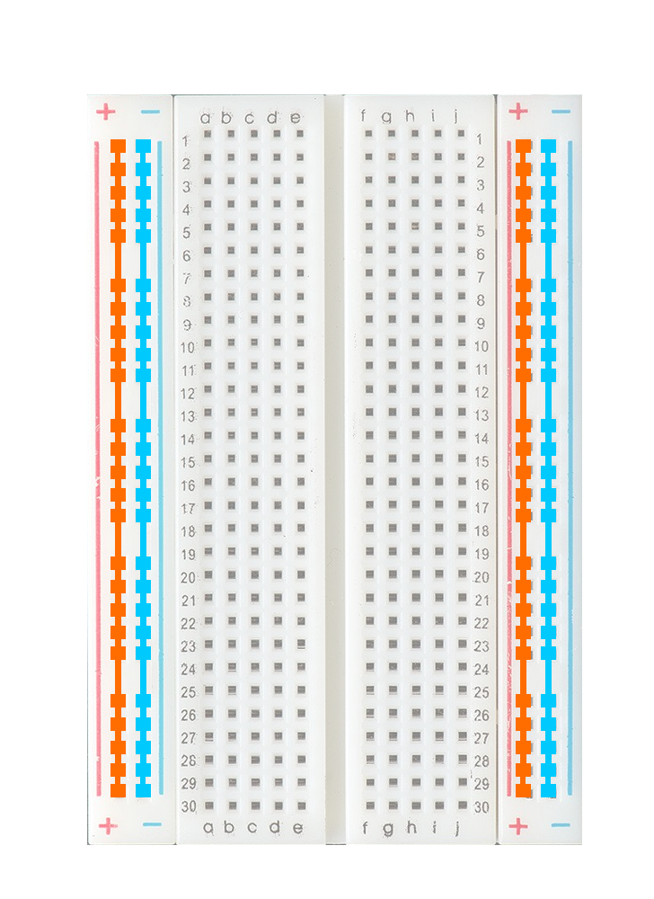
The first set of interconnected holes are the vertical rails. These are most commonly used to supply power and ground to the devices on the breadboards, to they often come pre-labeled with positive and negative signs. Keep in mind that this is just a suggestion, there is nothing stopping you from using these rails for some other type of electrical connection. For instance, if you are prototyping some kind of bus with multiple devices, you may decide to make the one set of rails power and ground, and the other set the TX and RX lines for the serial connection. You'll learn more about different kinds of serial buses in later sections. You should also note that the power and ground on the right side are NOT connected to the power and ground on the left. If you want them to be connected, you must implement that connection yourself.

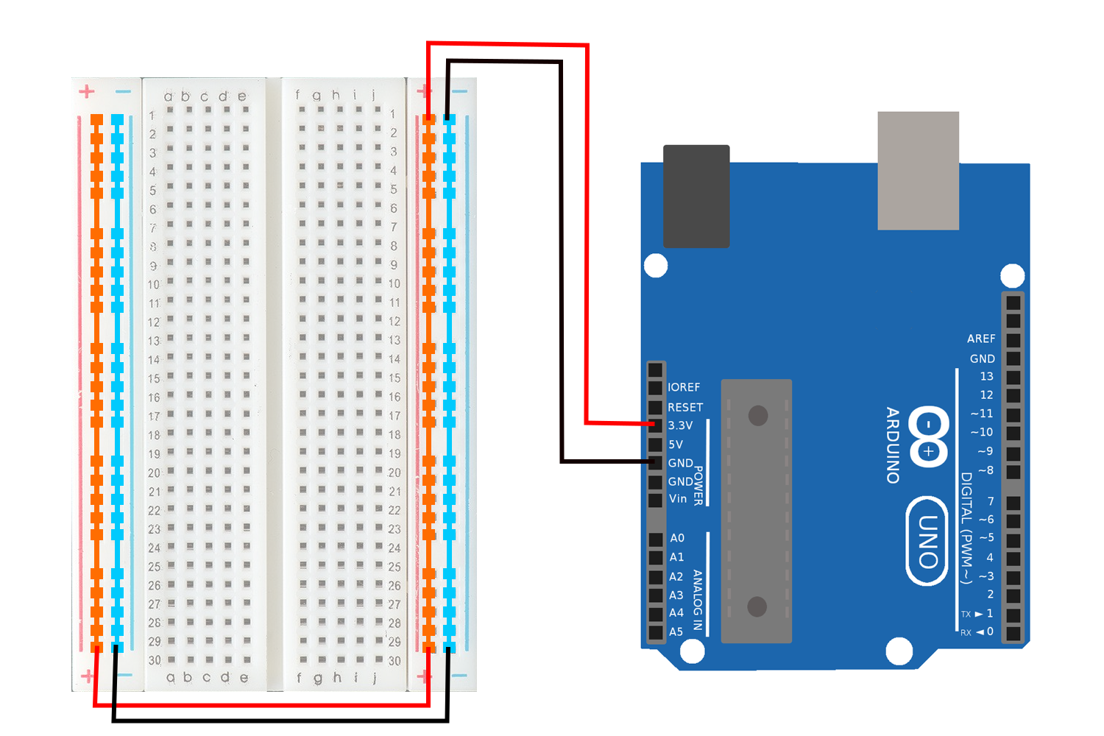
Below is an example where the breadboard has been wired to the Arduino to energize the ground and power rails as a 3.3V circuit. Notice that we are connected to the 3.3V and GND pins on the Arduino. Notice also that we have connected the power and ground on the left and ride side with wires.

- Wire your Arduino to the breadboard as shown in the image above. You may omit the wires connecting the lef and right ground and power rails, we will not be using them in this example.

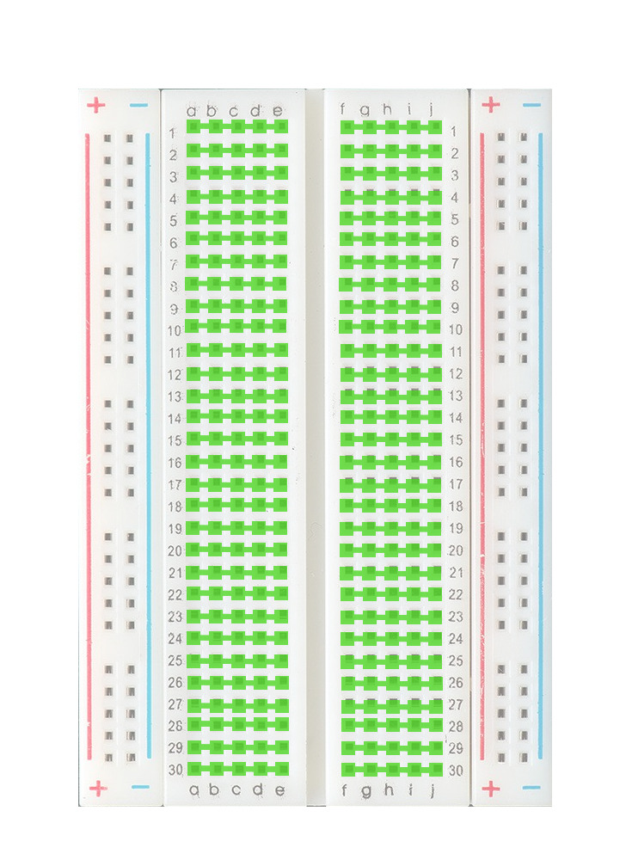
The other set of interconnected holes are the rows. These are the holes to which we typically attach the devices we wish to connect. Note that each hole is a row is connected to the other 4 holes in its row. Also note that the rows on either side of the center gap are not interconnected. This allows us to connected devices with a format known as Dual Inline Package (DIP) without shorting the pins on one side of the device to the pins on the other as shown in the image below.
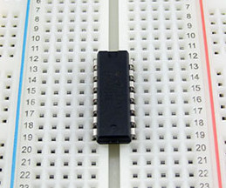

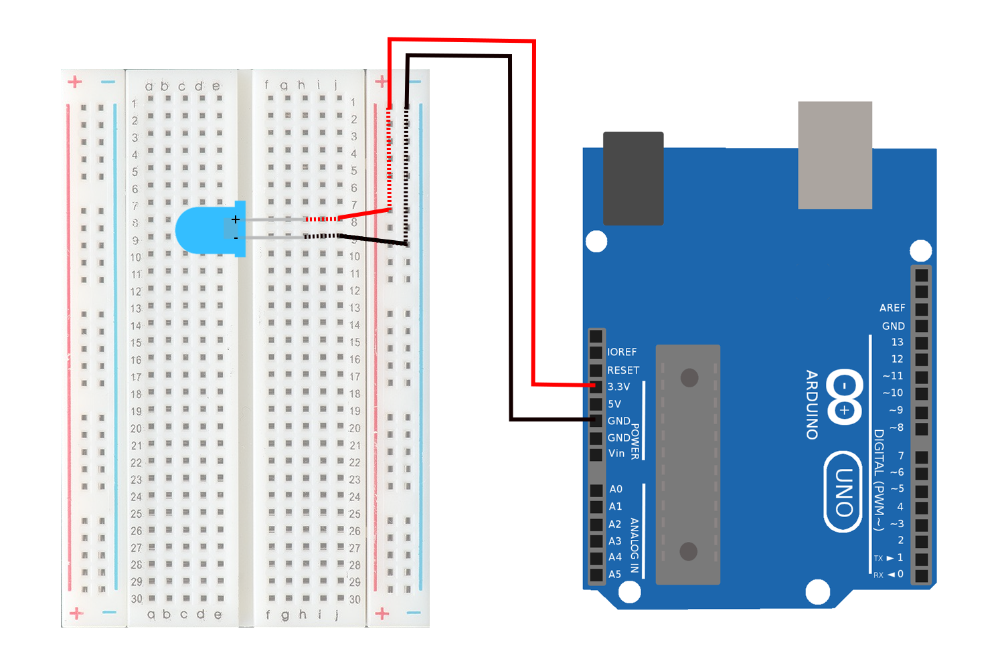
Below is an eample of an Adruino powering an LED with a 3.3V source throught the breadboard. The part of the electrical connection that is implemented with wires is colored solid. The part of the electrical connection that is implemented by the internal connections of the boardboard is colored with a dashed line.

- Add an LED to the circuit you wired before as shown above. Note that the positive leg of the LED is the long one, and the negative leg of the LED is the short one.
- Cut and place a small 'jumper' wire to connect the row for the positive leg of the LED to the power rail
- Cut and place a small 'jumper' wires to connect the row for the negative leg of the LED to the ground rail.

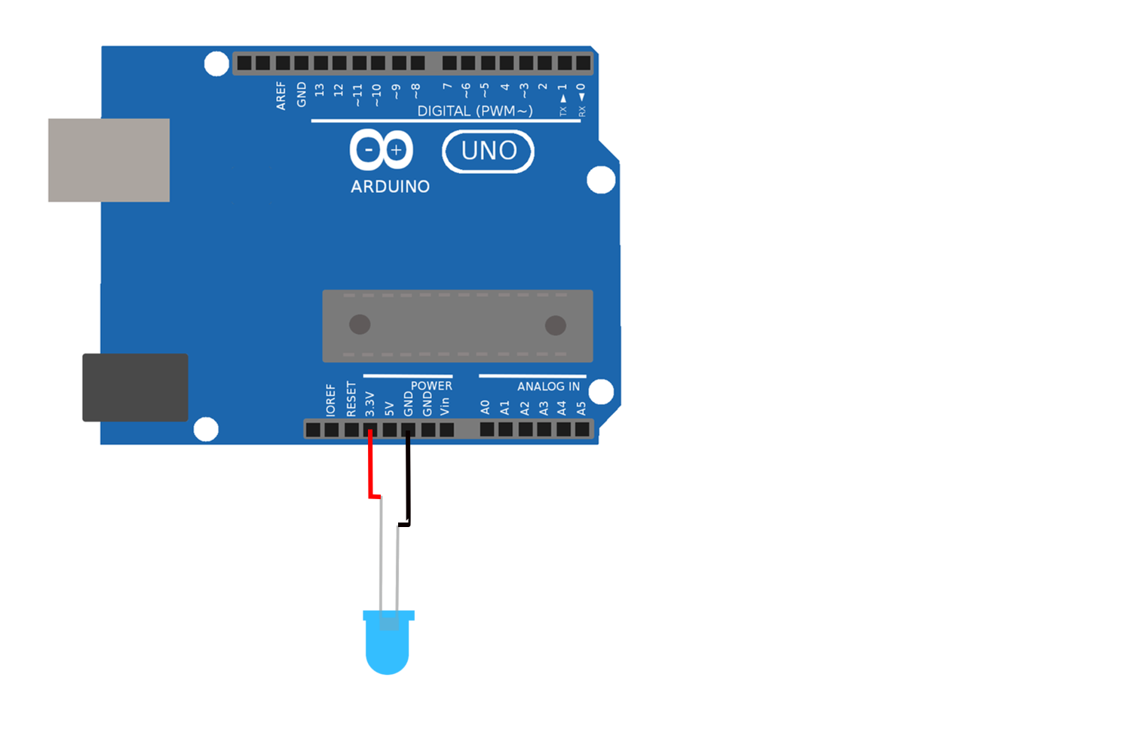
For the remainder of this course you should not expect to be given explicit wiring diagrams like the one above. Instead you should be able to take a schematic like the one below and create a wiring pattern that successfully implements it:

